Project Design Phase
Solution Architecture
Date | 13 February 2026
Team ID | InfiniteLoops
Project Name | Exploratory Analysis of Rainfall Data in India for Agriculture
Maximum Marks | 4 Marks

Overview
Solution architecture bridges business goals (supporting farmers and stakeholders with rainfall insights) and the technical implementation (EDA, ML models, and a Flask web application). The architecture defines system components, data flow, interfaces, and deployment considerations.

Key Goals
• Provide a reliable, easy-to-use rainfall analysis and prediction system
• Ensure modularity for preprocessing, modeling, and UI layers
• Enable scalability for adding regions, datasets, and real-time APIs
• Maintain reproducibility via saved artifacts (model, scaler, encoder)

Architecture Components
Frontend (UI): HTML/CSS/JS forms for user inputs and result visualization.
Backend (API): Flask server exposing endpoints for prediction and serving templates.
Preprocessing Layer: Imputer, Encoder, Scaler to prepare inputs consistently.
ML Model Layer: Trained classifier/regressor (Random Forest/XGBoost).
Data & Artifacts: Historical rainfall datasets and serialized model files (.pkl).

Solution Architecture Diagram
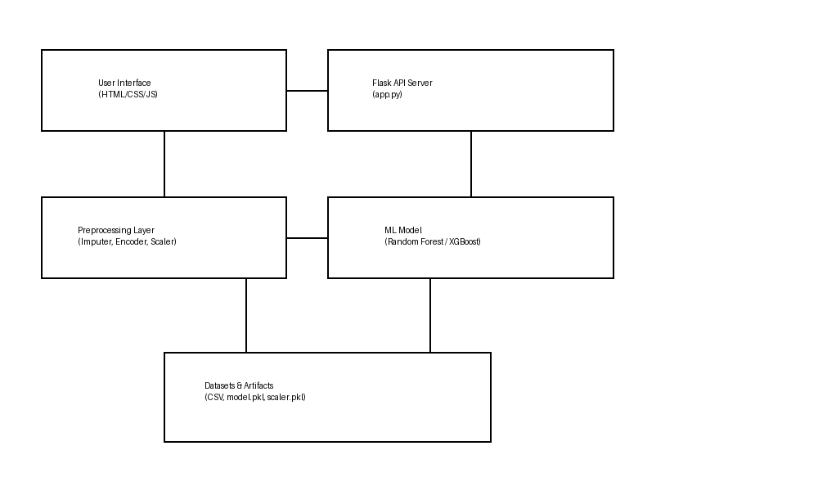

Data Flow
1) User submits weather parameters via UI.
2) Flask API receives request and validates inputs.
3) Inputs pass through preprocessing (imputation, encoding, scaling).
4) Preprocessed features are sent to the ML model for prediction.
5) Prediction is returned to UI with visual feedback (rain/no-rain & insights).

Non-Functional Considerations
• Performance: Low-latency inference for real-time UX
• Reliability: Consistent preprocessing via saved artifacts
• Security: Input validation and safe model loading
• Maintainability: Modular components and clear interfaces
• Deployability: Ready for cloud deployment (Docker/VM) in future

